Exercise 10

- Display the sum of ages of employees working at Bignet.
SELECT SUM(age) AS total_age FROM employee_data;
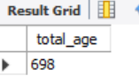
- How would you calculate the total of years of service the employees of Bignet have in the company?
SELECT SUM(yos) AS total_years_of_service FROM employee_data;
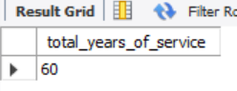
- Calculate the sum of salaries and the average age of employees who hold “Programmer” title.
SELECT SUM(salary) AS total_programmer_salary, AVG(age) AS avg_programmer_age FROM employee_data WHERE title = 'Programmer';
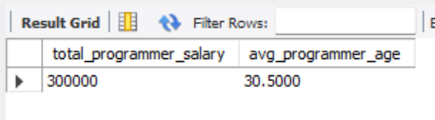
- What do you understand from the following statement?
SELECT (SUM (perks) /SUM (salary) * 100) from employee_data;
SUM(perks) this adds all perks of the employees
SUM(salary) this add all salaries of all employee
Then it divides perks by salary and then multiplies by 100

